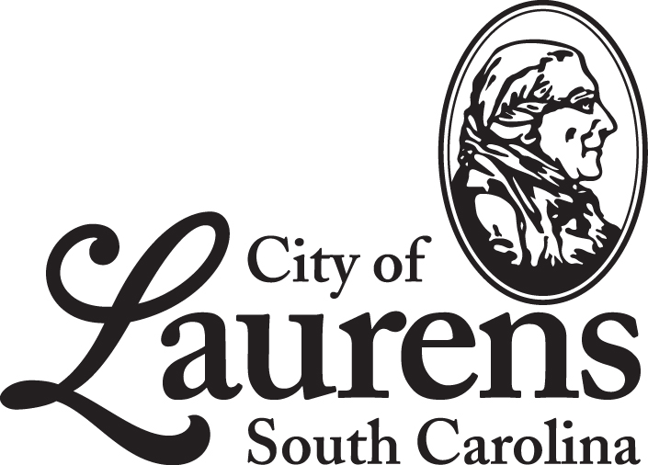

City Council Meeting Agenda: Special Called Meeting

Laurens City Hall
126 East Public Square, Laurens SC 29360
Tuesday January 11, 2022 5:30pm
- Ordering the Business of Council
- Call to Order Mayor Nathan Senn
- Invocation* Councilor Alicia Sullivan
- Pledge of Allegiance

- Public Participation & Hearing

- Public Comment.
Those requesting to address City Council during the public comment period must sign up to speak prior to the meeting being called to order, and all are requested to limit their remarks to no more than three (3) minutes, subject to the discretion of the Chair.

- Reports & Communication
- City Councilor Reports
- Mayor’s Report Mayor Nathan Senn

COUNCIL BUSINESS

- Consent Agenda
All items under the Consent Agenda are considered to be routine in nature and will be enacted by a single motion and subsequent omnibus vote. There will be no separate discussion of these items unless a City Council member so requests, in which event the item will be removed from the Consent Agenda and considered as the first item after approval of the Consent Agenda.

- Approval of the Council Agenda for January 11, 2022
- Approval of Minutes from the Regular Council Meeting of December 21, 2021

- Old Business

- Mayor Nathan Senn presenting second reading Ordinance 12-21-01 To Annex 914 East Main Street to the Territorial Limits of Laurens, South Carolina.
- Mayor Nathan Senn presenting second reading Ordinance 12-21-02 Amending Ordinance No. 10-20-21
(Land Sale to SK Builders, INC).

- New Business

- Mayor Nathan Senn presenting first reading Ordinance 1-22-01 To rezone property at 375 Exchange Dr., Tax Map #906-20-01-109 from R3 to B4.

- Executive Session

To discuss a property matter.

- Adjournment

Motion to Adjourn Mayor Pro Tempore

Public Notices

Public Viewing of City Council Meetings: All meetings of the Laurens City Council are available to be viewed by the public and are streamed live on the City’s YouTube channel, which may be accessed at the following address:
https://www.youtube.com/c/CityofLaurensSouthCarolina

A link to this channel will be posted on the City of Laurens’ web site and Facebook page prior to each meeting.

Addressing City Council: Those wishing to be included on the Council’s Agenda during the Public Participation & Hearing portion of regular city council meetings must submit a written request to the City Administrator no less than one (1) week prior to each meeting, which are usually held on the third Tuesday of each month. Forms for requesting to address City Council are available at City Hall and will gladly be provided upon request. Those who are included on the Council’s agenda are requested to limit their remarks/presentation to no more than five (5) minutes, subject to the discretion of the Chair.

Statement Regarding Compliance with the Americans with Disabilities Act (ADA): The City of Laurens wishes to ensure that its programs, services, and activities are accessible to individuals with disabilities. All City Council meetings are wheelchair accessible. Persons who require an auxiliary aid or service for effective communication, or a modification of policies or procedures to participate in a program, service, or activity of the City of Laurens should contact the City Administrator at (864) 984-3933.

We would appreciate advance notice of at least 48 hours for any requests to receive an agenda in an alternate format or other types of auxiliary aids and services.

Note: All minutes are drafts until approved at the subsequent meeting of City Council. The City of Laurens will post the approved minutes on their web site within 30 days of approval.

About Us: The City of Laurens, South Carolina is a thriving, growing city of approximately 9,000 residents and it is located in the heart of Laurens County, the gateway to the Upstate region. The city, which was originally incorporated in 1845, serves as the seat of county government, and has played an influential part in shaping the history of our state, from the time of the American Revolution, throughout the twentieth century, and into the present day. As a center of manufacturing and industry, the City of Laurens has seen a rebirth from what was once a town dominated by textile mills to its present status as a forward-thinking city with a wide variety of manufacturing and industrial employers. It is a place which celebrates and values its history, while striving to welcome and encourage growth and the prosperity of all of its citizens and businesses.

